Functional Programming in Haskell

Assessed Coursework: 2 Marks: 20 Duration: 40 minutes

NAME: ........................................................……......LOGIN…………..………

1. The following is a generalisation of the binary tree data type in which each node is allowed to contain four sub-trees instead of two; such trees are often called QuadTrees (here abbreviated to QT). Note that the data type is polymorhic.

data QT a = Tip | Parent a ( QT a ) ( QT a ) ( QT a ) (QT a )

In what follows assume that this definition has been entered into the Haskell script.

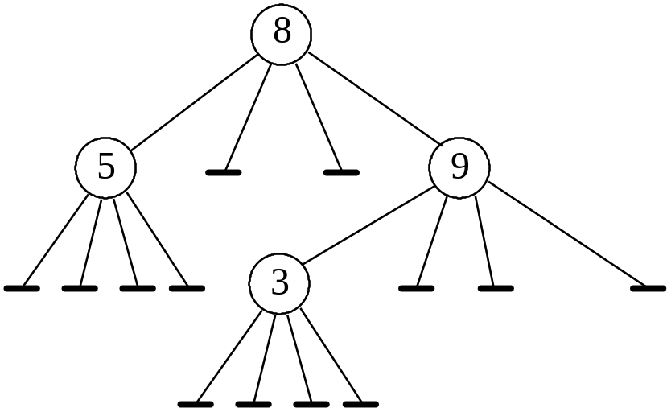
1a. Write down the representation of the following tree as an object of type QT Int (the horizontal bars indicate tips): [2 marks]

Representation:

1b. Define a function rootVal that will return the value stored at the root (topmost node) of a non-empty tree of type QT a. For example given the above tree it should return 8. [1 mark]

rootVal :: QT a -> a
--Pre The tree is non-empty

1c. Define a function tips for computing the number of tips in tree of type QT a. For example, given the above tree it should return 13. [3 marks]

tips :: QT a -> Int

1c. Using the built-in function max (or maximum), or otherwise, define a function maxElem for computing the largest element in tree of type QT Int containing only non-negative integers. If the tree has no elements the function should return 0. When applied to the above tree, for example, it should return 9. [3 marks]

maxEl :: QT Int -> Int

2. Work out the most general types of the following functions. Note that the built-in function tail has type [a]->[a] with the definition tail (x:xs) = xs; similarly, snd :: (a,b) -> b with definition snd (x,y) = y. [1,2,2 marks resp.]

Function | Type
f x  = x ++ [True,False] | f ::
f x y  = if x == y then x  else tail x | f ::
f x [] = [ x ]  f x ( y : ys )  = snd y : f x ys | f ::
3. Assuming the following functions and constants have been defined:

big x = x > 8
short xs = ( length xs < 4 )
lists = [ "One", "Two", "Three" ]

write down the values of the following expressions: [1 mark each]

Expression | Value
map length lists
zipWith (==) "bad" "boy"
filter big [ 1..10 ]
length ( filter short lists )

4. Rewrite the following functions definitions in terms of either map, filter or zipWith. Again, assume the functions big and short above have already been defined. [1 mark each]

Function | Alternative Definition
f [] = []
f ( x : xs )
= big x : ( f xs )

f [] = []
f ( x : xs )
= if short x
then x : f xs
else f xs

